Combat
Initiative
Combat is divided into rounds, each of which has 10 phases. You begin each round by rolling dice equal to your Void Ring plus 1 without spending void points or rerolling 10s, and keeping all but the highest die. These are called action dice because each represents one action, and the number showing on each die is the phase in which that action takes place.
Taking an action spends one action die in the current phase. An action die not spent in its phase becomes a held action, and may be spent in any future phase. Held actions not spent by the end of Phase 10 are lost. | 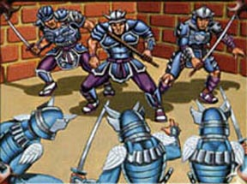
If two characters act in the same phase, the one with the lowest action die goes first. If this is tied, compare their second-lowest action dice, and so on. If they have the same action dice, the character with higher Void wins, and if their Void is tied then flip a coin.

Attacking and Parrying
All characters begin with two advanced skills at 1: attack (which uses Fire) and parry (which uses Air). Attacking has a TN of 5 plus 5 times the defender's parry skill. If the TN is not met, the attack fails. Otherwise, the defender may attempt to parry, with the TN being the result of the attack roll. Characters may parry for each other, but the TN is raised by 5 times the attacker's attack skill. If a parry succeeds, the attack fails.

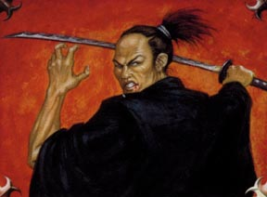 | If your character wishes to parry but has no actions in the current phase, you may take an interrupt action. Spending any 2 action dice creates an interrupt action in the current phase, which may be used to parry. If you decide to parry before the attack is rolled, you get a free raise to your parry.

Damage
Your base damage depends on your weapon and Fire. This damage starts at 4k2 for katana, 3k2 for spears and wakizashi, 2k2 for knives and other small weapons, and 0k2 for unarmed fighting. You also add your Fire to the number of rolled dice of your base damage. You can't spend void points on damage, but you roll an extra die for every 5 by which your attack roll exceeded its TN. If the defender attempted and failed to parry, you don't roll these extra damage dice. | 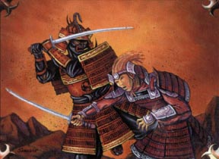
When your characters gets hit, the damage is added to your character's light wound total. You then roll (Water+1)k(Water) as a wound check. The TN for this roll is your character's light wound total.
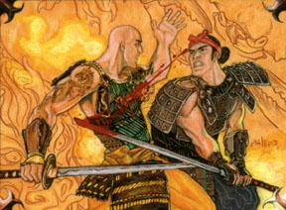 | If you fail this roll, your character takes 1 serious wound plus 1 serious wound for every 10 by which you failed the wound check, and the light wound total is set back to 0. If you succeed, you may either keep all light wounds or take 1 serious wound to reduce the light wound total to 0.
When the serious wound total meets or exceeds your character's Earth Ring, your character is crippled. While crippled, and you no longer reroll 10s for any skill, but you still reroll 10s on non-skill rolls such as wound checks and damage rolls. You may spend a Void Point after seeing a roll to reroll the 10s while crippled. When the serious wound total reaches twice your character's Earth Ring, your character is mortally wounded and unable act.
Characters heal 1 serious wound every other night, starting the first night after damage is taken. The GM may decide to speed this up or slow it down depending on the physical exertion your character undergoes while wounded. Light wounds can be automatically healed after combat with rudimentary first aid.

Iaijutsu Duels
Before a duel begins, you stand motionless a few feet from your opponent and show your stance. Each duelist makes an open roll to discern the opponent's Fire Ring, using iaijutsu with Air. This tells you that your opponent has at least X Fire, where X is your roll divided by 5 (rounded down). If X exceeds their Fire, you know for certain what it is.
After this, the participants make a contested iaijutsu roll. The TN to hit each duelist begins at their experience point total divided by 10, rounded down. The duelists take turns choosing whether to focus or strike. The winner of this contested roll chooses first.
When you declare a focus, the TN to hit your character is raised by 5. When a strike is declared, both duelists attack simultaneously using iaijutsu. You roll 1 extra damage die for every 1 by which your iaijutsu roll exceeded its TN instead of for every 5, and each rolled die above 10k10 adds +5 instead of +1. Void points can't be spent and 10s aren't rerolled on either these rolls or the wound checks they cause.
If neither participant hits, both duelists resheathe their katana and restart the duel. Whoever rolled higher receives a free raise on their damage roll if they hit on a future strike. Both characters get this free raise if they roll the same amount. When at least one duelist hits, the duel switches from iaijutsu to kenjutsu, and normal combat rules apply.
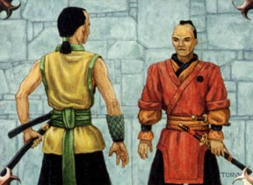 | 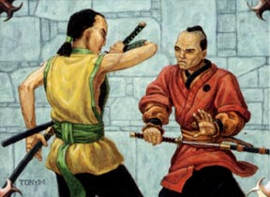 | 